Team members:
- John Benedict Castroverde
- Giuliano Di Fulvio
- Kodji Crédo Dotse

Deliverable 1:

Responsibilities
- John: handles the project preparation and description
- Giuliano: handles the JDBC and DAO in the program
- Credo: handles the database and SQL

Features
- Logging in as either the administrator or a participant with authentication
- Display of all available conferences along with their information

Administrator’s responsibilities and capabilities
- CRUD (Create, Read, Update, Delete) for processing participant’s data
- Handling conference capacity and participant queues
- Creating and deleting conferences

Participant’s responsibilities and capabilities
They can log in or create an account to view available conferences, register for one, enter a queue or leave one, and edit their profile information.

Conferences
A conference must feature:
- Capacity
- Confirmed participants
- Available seats

JavaFX scenes
Upon running the program, the user will see:
- The log in screen
- The sign-up screen
After logging in or creating an account, the user will see:
- The dashboard showing whatever the user clicked in the side bar (Registered Conferences is the scene shown by default)
- A side bar showing a View Profile, Join Conference, Registered Conferences, Conferences in Waiting, and Manage Conferences options
- View Profile will lead the use to their profile where they can edit information
- Registered Conferences shows the user the conferences they have a spot in
- Conferences in Waiting will show the user conferences they’ve applied to. But don’t have a spot yet
- Join a Conference will lead the user to a list of active conferences where they can register for one
- Manage Conferences allows the administrator to view information about each conference and modify them

Data Flow
Can someone fill this part since it involves the database

Visuals
These visuals can be found in the Program sketches folder. The final product will look different.

Log in
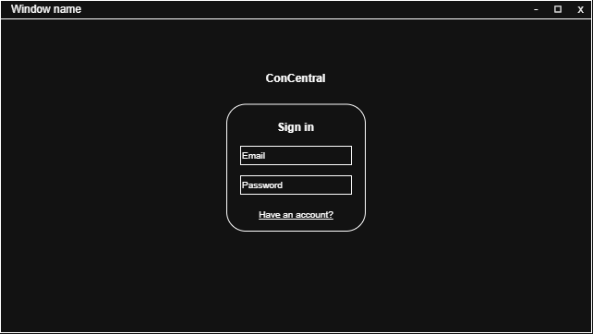

Sign up
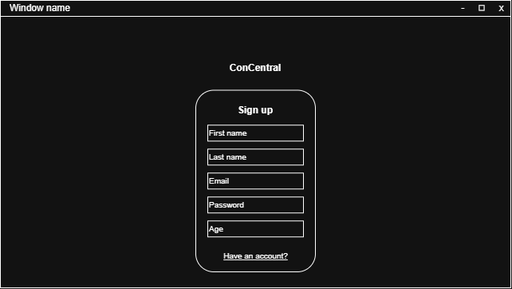

Registered conferences
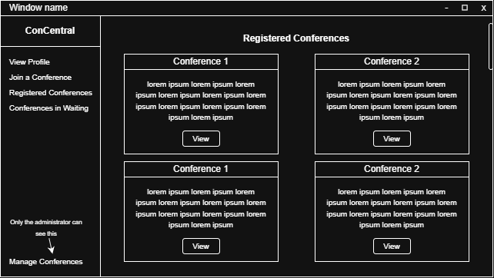

View conference
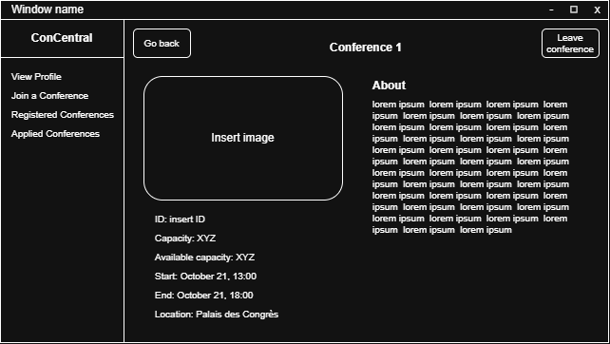

Applied conferences
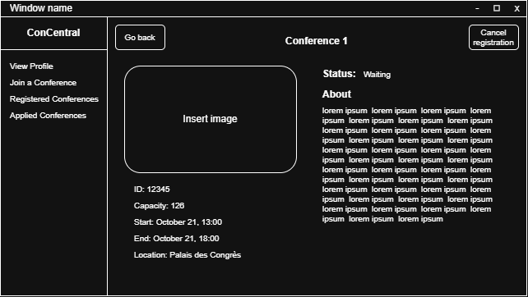

View conference in waiting
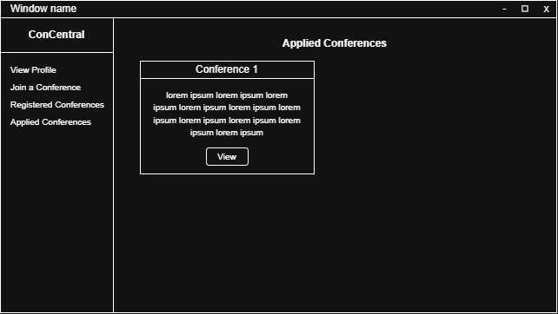

View profile
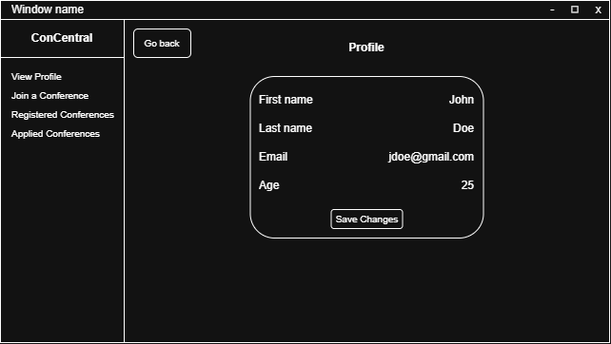

Manage conferences
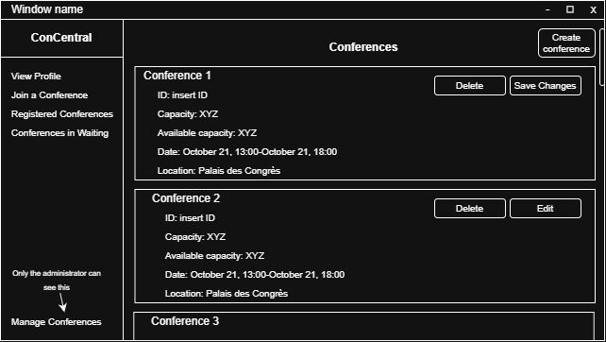

TO SUBMIT
Project description of document, IntelliJ project with the JDBC and DAO implementation, and ER diagram and SQL files (they’ll all be in the ZIP file anyway)

